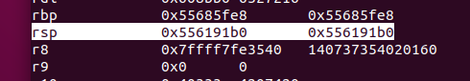

빼기한 것은 55 61 91 78

touch 2는 7c 18 40 00 00 00 00 00

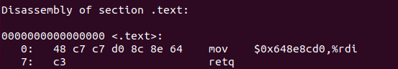

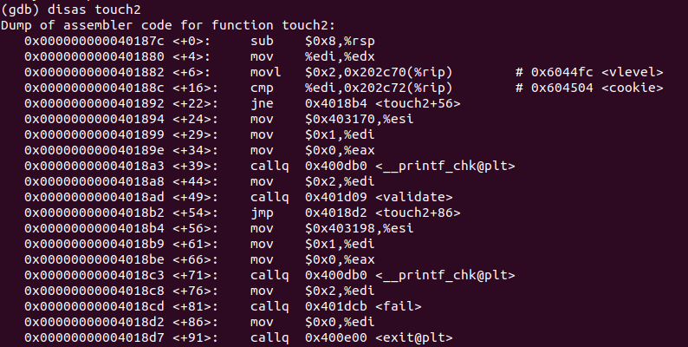

phase2

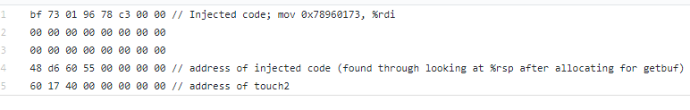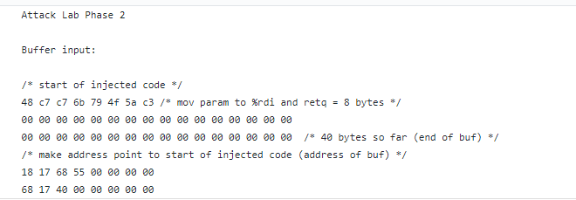

phase3

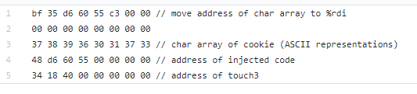

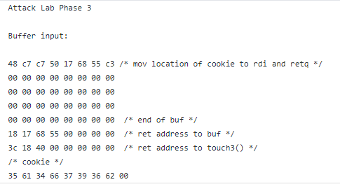

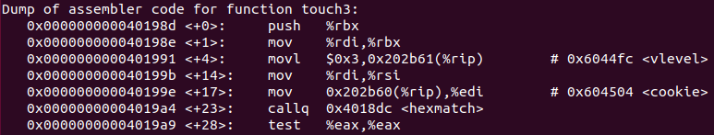

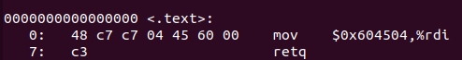

rtarget

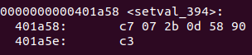

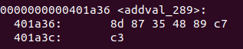

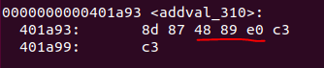

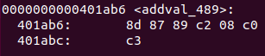

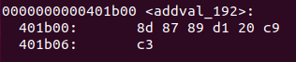

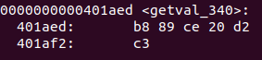

https://github.com/BenShoeman/csci2400-computer-systems/blob/master/AttackLab/rtarget.3.comments.txt